Standard Operating Procedures (SOPs) for Quantitative Data Collectors

SOP 1: First home visit with pregnant women
- Within 24 hours of receiving the contact information of a pregnant woman from the health center, make a home visit to that woman.
- On arrival to her home, greet the pregnant woman and introduce yourself as a staff member of Helen Keller International Cambodia.
- Read the consent form to the pregnant woman. Answer any questions she may have about the study.
- If the woman agrees to participate in the study, ask her to sign 2 copies of the consent form.
- Leave one copy of the consent form with the pregnant woman and take the other copy with you when you leave. Store this copy in a safe place until you can hand it to your supervisor or the project manager.
- Confirm with the pregnant woman that she received her pills (either IFA or MMS) from the health center. If she has not, please inform the woman that she will need to return to the health center to get her pills.
- If possible, organize with the pregnant woman the date of her next house visit (try to schedule this visit 30 days from her study enrollment date. If this is not possible, the visit can be in 25-35 days.)

SOP 2: Data collection visits
Visit schedule
 | 30 days | 60 days | 90 days | 120 days | 130 days | 150 days | 180 days
IFA
Survey | x | x | x
Pill count | x | x | x
MMS
Survey | x | x | x |  | x |  | x
Pill weight | x | x | x | x |  | x | x

Note: while the days above represent the ideal timeline for data collection, ±5 days of each target date is acceptable (example: the 60-day visit can be done at 55-65 days post-enrollment).

On arrival to a woman’s home
- Introduce yourself and remind the woman that you work with Helen Keller International. Ask them if they have time to complete with you their study visit.
- Find a comfortable spot for you and the pregnant woman to sit. Ideally, this should be away from other household members to avoid having the woman’s answers influenced by others.
- If you are doing both the survey and the pill count/weight at this visit, start by doing the survey.

“Acceptability and Adherence” survey
- Open the “Adherence and Acceptability” survey form on your tablet and enter in the identifier information.
- Obtain consent from the women to proceed with the survey.
- On the first data collection visit, you will be prompted to fill out the background information for participants. Guidance for specific background questions:
- Highest degree/level of education: record the highest level completed. If a woman attended grade 1 but never completed it, enter “none”. Only select “non-formal education” if the participant did not complete any other education category levels listed. Example 1: A woman never attended primary school but took a literacy course “non-formal education” would be checked off. Example 2: A woman completed class 6 of primary school and also took many years of English language courses. “Primary” would be checked off.

Level | Definition
None | Never attend any kind of formal or non-formal education
Primary | Grades 1 to 6
Secondary | Grades 7, 8, and 9
Higher Secondary | Grades 10, 11, and 12
University and above | University and above
Non-Formal  Education (NFE) | Includes public and private courses on literacy and vocational  training usually conducted by the Government or NGO  (examples: hairdressing, sewing, typing, literacy courses, life  skills programs, or religious classes)

  - Marital status: select the category that corresponds to the woman’s current marital status. “Married” includes registered and unregistered marriages. “Separated” means that the woman was married and still is married but is no longer together with her husband. If a woman is both never married and cohabitating with a partner, select “Cohabitate with partner”.
- Go through all the questions listed in the survey, one by one. Read the question to the woman as well as all the answer options. Record the woman’s answer before moving on to the next question. Guidance for specific questions:
  - “What was the last date that you visited the health facility for ANC?” and “Which week of your pregnancy was, that you visited last time for ANC?” Please verify the woman’s responses using the ANC card.
  - Likert scale questions: in this section, you will ask women to provide their opinion or reaction based on a scale. The options are “strongly disagree”, “disagree”, “neutral”, “agree”, and “strongly agree”. For these questions, display the printout of the 5 mood emojis for the pregnant woman to see. Read the question out loud and ask the woman if she strongly disagrees, disagrees, is neutral, agrees, or strongly agrees with the statement. Record the woman’s answer, then move on to the next question,
- Once all questions in the “Adherence and Acceptability” survey have been answered, click “Save”. If you are confident that all answers were correctly recorded, click on the check box and press “Send finalized form”. Note: you cannot undo this action. Please be sure the survey is complete and ready to send before proceeding with this step.

Pill weight (MMS-90 and MMS-180 study arms)
- Open the “Monthly Pill Weight Data Collection Sheet” in your tablet.
- Record all identifier information and indicate the participant’s study arm (MMS 180 or MMS 90), month of visit, and gestational age.
- For MMS-90 and MMS-180 study arms: Proceed with pill weight activity.
  - Ask the woman to provide you with her pill bottle.
  - Sanitize your hands before handling the pill bottle.
  - Open the bottle and ensure the desiccant is inside. Record the presence or absence of the desiccant in the form.
  - Find a flat surface.
  - Place the plastic box on the flat surface and place the scale inside.
  - Turn on the scale and close the lid to the box.
  - Ensure a weight of “0” is indicated on the scale. If a number other than “0” is displayed, try moving the box or turning the scale off and on.
  - Once a “0” is obtained, open the box lid, place the pill bottle on the scale, and close the lid.
  - Record the weight indicated on the scale.
  - Refer to the chart with the pill weights to determine how many pills are estimated to be in the bottle. (The steps are described below, and an example can be found at the end of this section).
    - Find the column that corresponds to your specific scale.
    - In that column, find the reference weight that is closest to the one on your scale.
    - Write down on a piece of paper (or in your phone) that reference weight and the one above and below it.
    - Subtract the weight on your scale from each of the three reference weights identified above.
    - Use the reference weight that gives the smallest difference to find the estimated pill count. To do this, look across the row of the reference weight to the first column of numbers. This is where you’ll find the estimated pill count for that reference weight.
    - Write that estimated pill count in your ODK form.
  - Open the box lid and remove the pill bottle. Wait until a “0” is displayed on the scale. If a number other than “0” is displayed, close the box lid. If this does not resolve the issue, try moving the box or turning the scale off and on.
  - Proceed with the steps h, i, j & k to weigh the pill bottle a 2nd time and determine the estimated pill count.
  - Repeat steps h, i, j & k a 3rd time to obtain a total of 3 weights and 3 estimated pill counts.
- Go through the remaining questions in the pill weight survey.
- When all the questions have been completed, click “Save”. If you are confident that all answers were correctly recorded, click on the check box and press “Send finalized form”. Note: you cannot undo this action. Please be sure the survey is complete and ready to send before proceeding with this step.

Example of determining estimated pill count
In this example, you are weighing a 90-count MMS pill bottle at the first month visit, and you have scale #1. The weight on your scale is: 55.89g. Here are the steps you would follow:
- Enter 55.89 in ODK.
- Look at the column for scale #1 in the pill weight chart.
- Find the reference weight that seems closest to 55.89. In this case, you think that 55.57 might be closest to the weight on your scale.
- Write that reference weight down, along with the number above it and below it in the chart. So, you would write down: 55.11, 55.57, and 56.04.
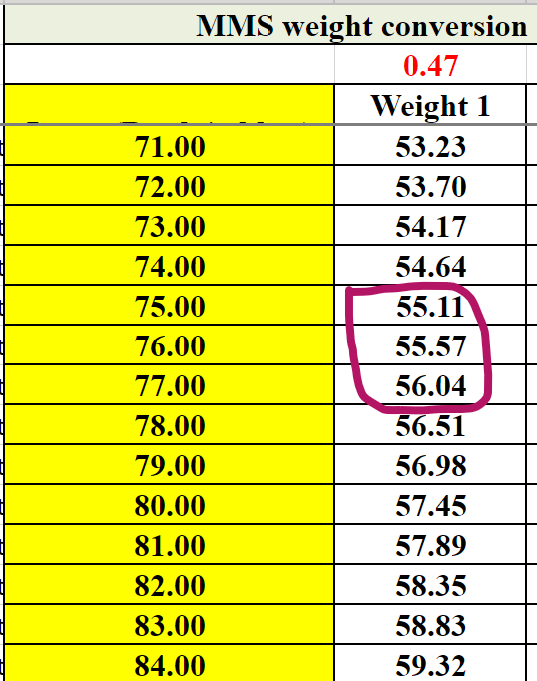
- Calculate the difference between each of these reference weights and 55.89 (the number on your scale).
  - 55.11 - 55.89 = -0.78
  - 55.57 - 55.89 = -0.32
  - 56.04 - 55.89 = 0.15
- Look at all three calculated numbers and determine which one is smallest. Ignore the “-” symbol and choose the smallest number. In this case, it’s 0.15.
- 56.04 was the reference weight we used to get the smallest difference of 0.15. Look at 56.04 on the chart to see what estimated pill count is in that row. In this case, it’s 77.
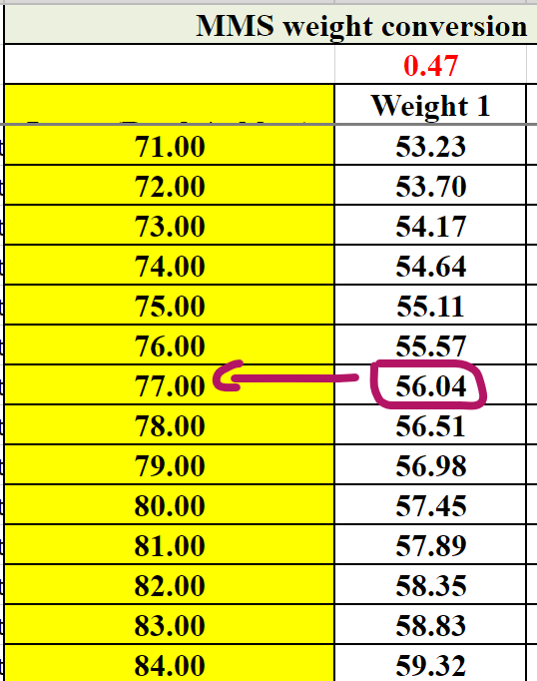
- Write 77 as the estimated pill count in ODK.

Pill count (IFA study arm)
For IFA study arm:
- Open the “Monthly Pill Weight Data Collection Sheet” in your tablet.
- Record all identifier information and indicate the participant’s study arm (MMS 180 or MMS 90), month of visit, and gestational age.
- Proceed with pill counting activity.
  - Ask the woman to provide you with her pill bag.
  - Sanitize your hands before handling the pill bag.
  - If possible, count the pills without opening the bag. If needed, you can remove the pills from their bag and place them onto a clean tray surface for counting.
  - Record your count in the ODK form.
  - Count the pills a second time and record this number in the ODK form. If the two counts are the same, you can continue to the next step. If they are not the same, count the pills a 3rd time and record that number in the ODK form.
- Go through the remaining questions in the pill count survey.
- When all the questions have been completed, click “Save”. If you are confident that all answers were correctly recorded, click on the check box and press “Send finalized form”. Note: you cannot undo this action. Please be sure the survey is complete and ready to send before proceeding with this step.

End of visit
- Provide the woman with the appropriate incentive (see table below).
- Thank the woman for her time.
- If possible, schedule the next visit with the participant. Try to schedule this visit 30 days from the ideal date of the previous visit (e.g., if this is the 2nd study visit, it should have ideally occurred on day 60 post-enrollment. Aim to schedule the next meeting on day 90 post-enrollment). If this is not possible, the visit can be 25-35 days from ideal visit date.

Incentives:
Study visit | Incentive
30-day (all participants) | Sarong
60-day (all participants)  90, 120, 130, and 150-day (MMS arms only) | Bar of soap
90-day (IFA arm only)  180-day (MMS arm only) | Towel

